Grove- Temperature and Humidity Sensor

|  |
| --- |
| **Contents**   [[hide](javascript:toggleToc())]   * [1 Introduction](http://www.seeedstudio.com/wiki/Grove-_Temperature_and_Humidity_Sensor#Introduction) * [2 Features](http://www.seeedstudio.com/wiki/Grove-_Temperature_and_Humidity_Sensor#Features) * [3 Applications](http://www.seeedstudio.com/wiki/Grove-_Temperature_and_Humidity_Sensor#Applications) * [4 Specifications](http://www.seeedstudio.com/wiki/Grove-_Temperature_and_Humidity_Sensor#Specifications) * [5 Usage](http://www.seeedstudio.com/wiki/Grove-_Temperature_and_Humidity_Sensor#Usage) * [6 Resources](http://www.seeedstudio.com/wiki/Grove-_Temperature_and_Humidity_Sensor#Resources) * [7 Support](http://www.seeedstudio.com/wiki/Grove-_Temperature_and_Humidity_Sensor#Support) |

Introduction

This is a multifunctional sensor that gives you temperature and relative humidity information at the same time. It utilizes a DHT11 sensor that can meet measurement needs of general purposes. It provides reliable readings when environment humidity condition inbetween 20% RH and 90% RH, and temperature condition inbetween 0°C and 50°C, covering needs in most home and daily applications that don't contain extreme conditions.

Model:[SEN11301P](http://www.seeedstudio.com/depot/grove-temphumi-sensor-p-745.html?cPath=144_147)

[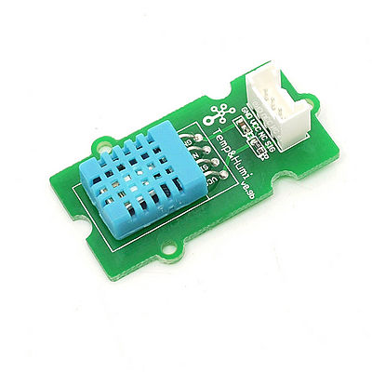](http://www.seeedstudio.com/wiki/File:Twig-Temp%26Humi.jpg)

Features 

* Provides detections over temperature and humidity
* Fully-calibrated
* Stable and reliable
* Suitable for average measurement applications

Applications

* Personal weather station
* Humidity regulator

Specifications

|  |  |  |  |  |  |
| --- | --- | --- | --- | --- | --- |
| **Items** | **Conditions** | **Min** | **Norm** | **Max** | **Unit** |
| VCC | - | 3.3 | - | 5 | Volts |
| Measuring Current Supply | - | 1.3 | - | 2.1 | mA |
| Average Current Supply | - | 0.5 | - | 1.1 | mA |
| Measuring Range | Humidity | 20% | - | 90% | RH |
| Temperature | 0 | - | 50 | °C |
| Accuracy | Humidity | - | - | ±5% | RH |
| Temperature |  |  | ±2 | °C |
| Sensitivity | Humidity |  | - | 1% | RH |
| Temperature |  |  | 1 | °C |
| Repeatability | Humidity |  |  | ±1% | RH |
| Temperature |  |  | ±1 | °C |
| Long-term Stability |  |  |  | ±1% | RH/year |
| Signal Collecting Period |  |  | 2 |  | S |

Usage

This demo is going to show you how to read temperature and humidity information from this Grove - Temperature and Humidity Sensor.

[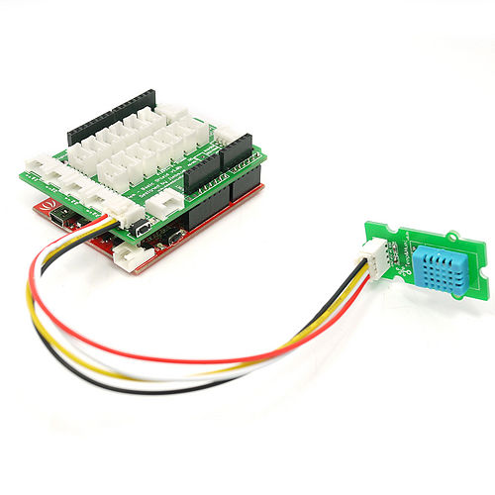](http://www.seeedstudio.com/wiki/File:Temperature_Sensor.jpg)

1.Connect the Temperature and Humidity sensor to analog port A0 of Grove - Base Shield.

2. Download [File:Humidity_Temperature_Sensor library](http://www.seeedstudio.com/wiki/File:Humidity_Temperature_Sensor.zip); Unzip and put them in the libraries file of Arduino IDE by the path: ..\arduino-1.0\libraries.

3. Restart the Arduino IDE. Open “DHTtester” example via the path: File --> Examples --> Humidity_Temperature_Sensor --> DHTtester. Through this demo, we can read the temperature and relative humidity information of the environment.  
  
[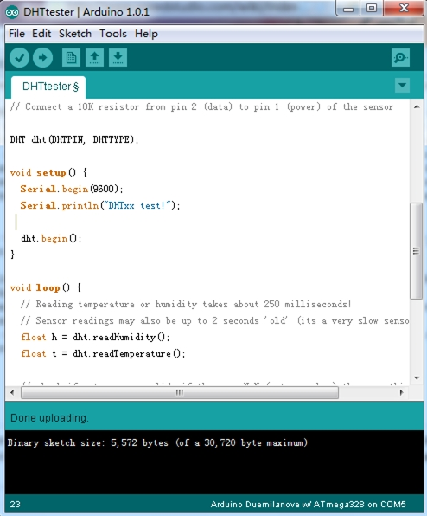](http://www.seeedstudio.com/wiki/File:DHTtester_code.jpg)  
  
**Note:**

This Grove - Temperature and Humidity Sensor and our another product [Grove - Temperature and Humidity Sensor Pro](http://www.seeedstudio.com/wiki/Grove_-_Temperature_and_Humidity_Sensor_Pro) are sharing this library. No matter which product you are using, make sure you make the definition line of the sensor of your board into effect and comment out the definition lines of other specs. For example, the sensor we use on Grove - Temperature and Humidity Sensor is DHT 11. So the definition part of the sensor spec should be:

#define DHTTYPE DHT11 // DHT 11

//#define DHTTYPE DHT22 // DHT 22 (AM2302)

//#define DHTTYPE DHT21 // DHT 21 (AM2301)

4. Upload it into your Arduino board. If you do not know how to upload, please click [here](http://www.seeedstudio.com/wiki/Upload_Code).  
5. Open the serial monitor, you can see the score as shown below:  
  
[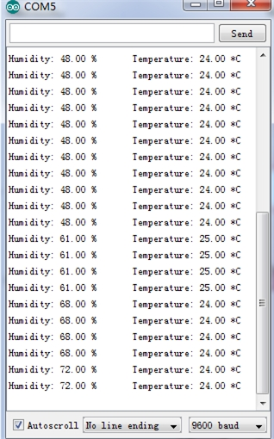](http://www.seeedstudio.com/wiki/File:Result_Picture1.jpg)

Resources

* [Temperature Humidity.zip](http://garden.seeedstudio.com/images/7/79/Temperature_Humidity.zip)
* [File:Humidity_Temperature_Sensor library](http://www.seeedstudio.com/wiki/File:Humidity_Temperature_Sensor.zip)